HARWOOD SCHOOL
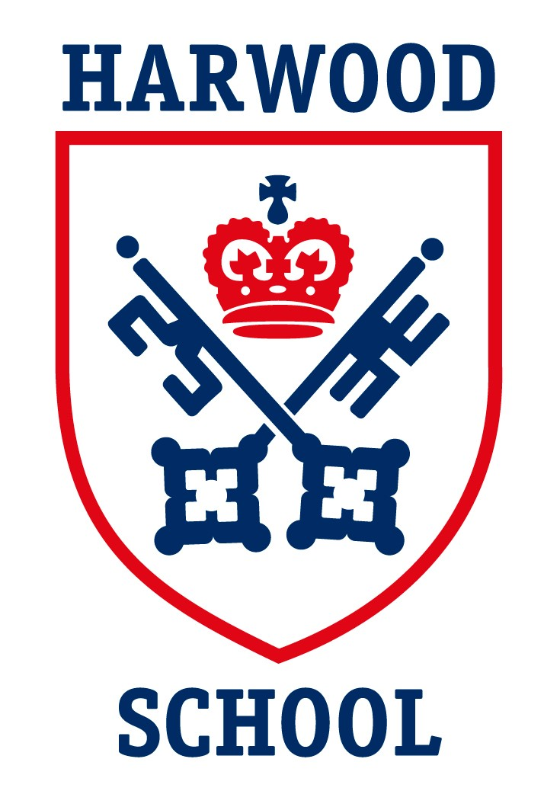
BOOKS 2021

PRESCHOOL
· KINDER
Dex the Dino PLUS – MACMILLAN
· TRANSITION
Discover with Dex 1 Plus – MACMILLAN
· PREP
Big Jungle fun - Activity book 3 – RICHMOND
PRIMARY
· FORM 1
BRIGHT IDEAS 1 class book (Cheryl Palin) OXFORD
BRIGHT IDEAS 1 activity book
OXFORD
WINNIE THE WITCH reader (edition for learners of English) PRESENT VERSION (Korky Paul – Valerie Thomas) OXFORD
LONGMAN’S CHILDREN’S PICTURE DICTIONARY with CDs -(Carolyne Graham) LONGMAN - PEARSON
· FORM 2
BRIGHT IDEAS 2 class book (Cheryl Palin) OXFORD
BRIGHT IDEAS 2 - activity book
OXFORD
WINNIE IN WINTER reader (edition for learners of English) PRESENT VERSION (Korky Paul – Valerie Thomas) OXFORD
LONGMAN’S CHILDREN’S PICTURE DICTIONARY with CDs - (Carolyne Graham) LONGMAN - PEARSON
ATENCIÓN: El mismo del año anterior.

· FORM 3
BRIGHT IDEAS 3 class book (Cheryl Palin) OXFORD
BRIGHT IDEAS 3 - activity book
OXFORD
MAGIC FINGER reader (Roald Dahl) - PUFFIN
LONGMAN’S CHILDREN’S PICTURE DICTIONARY with CDs -(Carolyne Graham) LONGMAN - PEARSON
ATENCIÓN: El mismo del año anterior.
· FORM 4
BRIGHT IDEAS 4 class book (Cheryl Palin – Sarah Phillips) OXFORD
BRIGHT IDEAS 4 - activity book - OXFORD
· FORM 5
COMPASS LEVEL 5 - Language LOG – RICHMOND
READING LOG - RICHMOND
· FORM 6
COMPASS LEVEL 6 - Language LOG - RICHMOND
Literature - Level 6 - Reading LOG - RICHMOND
Reader: OLIVER TWIST – OXFORD
SECONDARY – HARWOOD LEVELLED
· 1st FORM
Language: GOLD EXPERIENCE B1+ student's book (2nd edition + acceso a plataforma digital) - PEARSON
Literature: HARRY POTTER AND THE PHILOSOPHER'S STONE - reader (unabridged)
· 2nd FORM
Language: GOLD EXPERIENCE B2 - student's book (2nd edition + acceso a plataforma digital) - PEARSON
Literature: PETER PAN - reader (unabridged)
· 3rd FORM
Language: VENTURE INTO FIRST FOR SCHOOLS st's book - OXFORD
Literature: To be confirmed.
Business: BUSINESS STUDIES (5th edition) (Karen Borrington/Peter Stimpson) – HODDER (Se usa en 3rd & 4th form)
CAMBRIDGE IGCSE and O Level - OPTION B The 20th Century (Ben Walsh) - HODDER
ATENCIÓN: NEW EDITION (ROJO) (Se usa en 3rd & 4th form)
· 4th FORM
Language: COMPLETE ADVANCED (2nd edition) - CAMBRIDGE
Literature: SONGS OF OURSELVES volume 1 (blue) - CAMBRIDGE.
ROMEO AND JULIET - reader (unabridged)
Business: BUSINESS STUDIES (5th edition) (Karen Borrington/Peter Stimpson) - HODDER ATENCIÓN: El mismo del año anterior.
History: CAMBRIDGE IGCSE and O Level - OPTION B The 20th Century (Ben Walsh) - HODDER
ATENCIÓN: NEW EDITION (ROJO)
SECONDARY - LEVELLED ENGLISH
· 1st FORM
BEYOND A1+ - St's book (Robert Campbell, Rob Metcalf, Rebecca Robb Benne) - MACMILLAN
BEYOND A1+ - Workbook (Andy Harvey)
· 2nd FORM
BEYOND A2+ - St's book (Robert Campbell, Rob Metcalf, Rebecca Robb Benne) - MACMILLAN
BEYOND A2+ - Workbook (Nina Lauder, Ingrid Wisniewska)
· 3rd FORM
BEYOND B1 - St's book (Robert Campbell, Rob Metcalf, Rebecca Robb Benne) - MACMILLAN
BEYOND B1 - Workbook (Lynda Edwards, Ingrid Wisniewska)
· 4th FORM
To be confirmed.

